**Experimenty s QOS mechanizmom WRED**

Cieľom zadania bolo experimentovať s rôznymi QOS mechanizmami a overiť ako sa budú chovať.

**Scenáre:**

Vo všetkých scenároch sme použili: 4x TCP toky - 50 kbps

1x UDP tok - 50 kbps

Oneskorenia medzi jednotlivými tokmi boli 5 sekúnd. Dĺžka každého toku je 60 sekúnd.

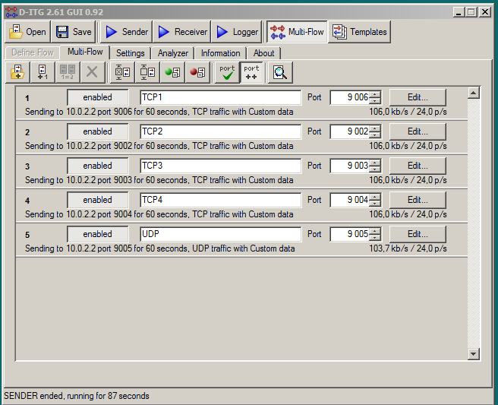

**1.FIFO**

Vygenerovaná prevádzka - nad kapacitu linky.

* 4 toky TCP: AF11, AF12, AF 31, AF 33

* 1 UDP tok: AF21

Príkazy na R1:

access-list 101 permit tcp any any eq 9006

access-list 102 permit tcp any any eq 9002

access-list 103 permit tcp any any eq 9003

access-list 104 permit tcp any any eq 9004

access-list 105 permit udp any any eq 9005

class-map match-all tok1

match access-group 101

class-map match-all tok2

match access-group 102

class-map match-all tok3

match access-group 103

class-map match-all tok4

match access-group 104

class-map match-all tok5

match access-group 105

policy-map znackovanie

class tok1

set dscp af11

class tok5

set dscp af21

class tok2

set dscp af12

class tok3

set dscp af31

class tok4

set dscp af33

interface FastEthernet0/0

ip address 10.0.1.1 255.255.255.0

duplex auto

speed auto

service-policy input znackovanie

**Graf FIFO**

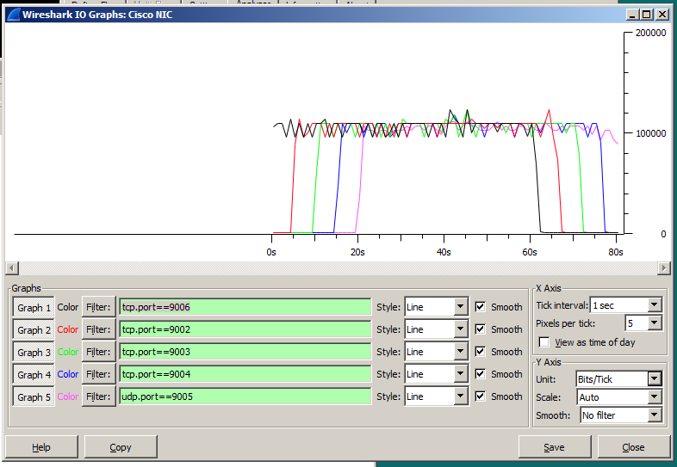

**Štatistiky z D-ITG**

Straty paketov sa nevyskytli pri žiadnom toku.

**************** TOTAL RESULTS ******************

__________________________________________________________

Number of flows = 5

Total time = 82.250000 s

Total packets = 7200

Minimum delay = -343.193000 s

Maximum delay = -340.770000 s

Average delay = -342.085402 s

Average jitter = 0.058319 s

Delay standard deviation = 0.530424 s

Bytes received = 3686400

Average bitrate = 358.555623 Kbit/s

Average packet rate = 87.537994 pkt/s

Packets dropped = 0 (0.00 %)

Average loss-burst size = 0 pkt

Error lines = 0

**2. CBWFQ**

Zmenili sme QOS mechanizmus na interface-i s0/0/0 z FIFO na WFQ v smere output a každej triede sme vyhradili minimálnu šírku pásma 25%.

policy-map CBWFQ

class tok1

bandwidth percent 25

fair-queue

class tok2

bandwidth percent 25

fair-queue

class tok5

bandwidth percent 25

fair-queue

class class-default

bandwidth percent 25

fair-queue

interface Serial0/0/0

bandwidth 128

ip address 10.0.12.1 255.255.255.0

clock rate 128000

service-policy output CBWFQ

**Graf CBWFQ:**

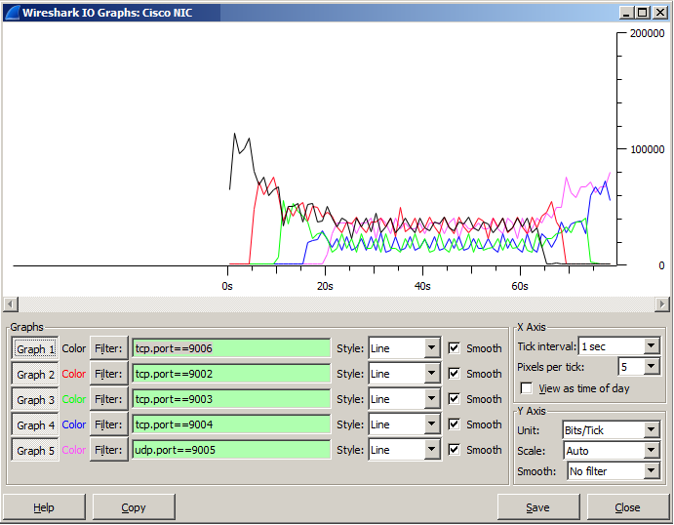

**Štatistiky z D-ITG**

Strata paketov nastala iba pri toku na porte 9005 - UDP tok.

Flow number: 5

From 10.0.1.2:64908

To 10.0.2.2:9005

----------------------------------------------------------

Total time = 61.497000 s

Total packets = 618

Minimum delay = 6.211000 s

Maximum delay = 9.599000 s

Average delay = 8.612042 s

Average jitter = 0.097754 s

Delay standard deviation = 0.524980 s

Bytes received = 316416

Average bitrate = 41.161813 Kbit/s

Average packet rate = 10.049271 pkt/s

Packets dropped = 822 (57.08 %)

Average loss-burst size = 2.439169 pkt

**************** TOTAL RESULTS ******************

__________________________________________________________

Number of flows = 5

Total time = 82.141000 s

Total packets = 2414

Minimum delay = 6.211000 s

Maximum delay = 21.483000 s

Average delay = 14.873799 s

Average jitter = 0.251116 s

Delay standard deviation = 4.282622 s

Bytes received = 1235968

Average bitrate = 120.375257 Kbit/s

Average packet rate = 29.388491 pkt/s

Packets dropped = 822 (25.40 %)

Average loss-burst size = 2.439169 pkt

Error lines = 0

**3.WRED**

Vytvorili sme nový policy mapu WRED a aplikovali na interface s0/0/0 v smere output.

policy-map WRED

class tok1

bandwidth percent 25

fair-queue

class tok2

bandwidth percent 25

fair-queue

class tok5

bandwidth percent 25

fair-queue

class class-default

random-detect

interface Serial0/0/0

service-policy output WRED

**Graf WRED**

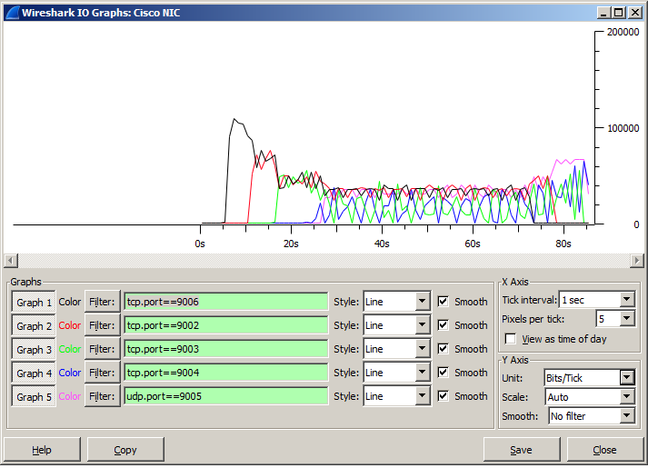

**Štatistiky z D-ITG**

Straty paketov nastali opäť iba na UDP toku. Straty boli o niečo menšie ako v prípade CBWFQ.

Flow number: 5

From 10.0.1.2:54515

To 10.0.2.2:9005

----------------------------------------------------------

Total time = 64.110000 s

Total packets = 631

Minimum delay = -342.878000 s

Maximum delay = -337.377000 s

Average delay = -338.691040 s

Average jitter = 0.095617 s

Delay standard deviation = 1.060283 s

Bytes received = 323072

Average bitrate = 40.314709 Kbit/s

Average packet rate = 9.842458 pkt/s

Packets dropped = 809 (56.18 %)

Average loss-burst size = 2.285311 pkt

**************** TOTAL RESULTS ******************

__________________________________________________________

Number of flows = 5

Total time = 85.811000 s

Total packets = 2507

Minimum delay = -342.878000 s

Maximum delay = -333.678000 s

Average delay = -338.335728 s

Average jitter = 0.164603 s

Delay standard deviation = 1.949060 s

Bytes received = 1283584

Average bitrate = 119.666150 Kbit/s

Average packet rate = 29.215369 pkt/s

Packets dropped = 809 (24.40 %)

Average loss-burst size = 2.285311 pkt

Error lines = 0

**4.WRED + ECN**

Nová policy mapa WRED_ECN, aplikovanie opäť na int s0/0/0 v smere output.

policy-map WRED_ECN

class tok1

bandwidth percent 25

fair-queue

class tok2

bandwidth percent 25

fair-queue

class tok5

bandwidth percent 25

fair-queue

class class-default

random-detect

random-detect ecn

Bolo nutné zadať do cmd na oboch PC príkaz (ako administrátor):

netsh int tcp set global ecncapability=enabled

Vo wiresharku sme odsledovali taký paket, ktorý bol označený smerovačom R1 tak, že keď túto značku uvidel R2, tak ho rovno zahodil. Na odsledovanie tohto konkrétneho paketu sme použili vo wiresharku príkaz tcp.flags.cwr == 1

**Výpis z wiresharku:**

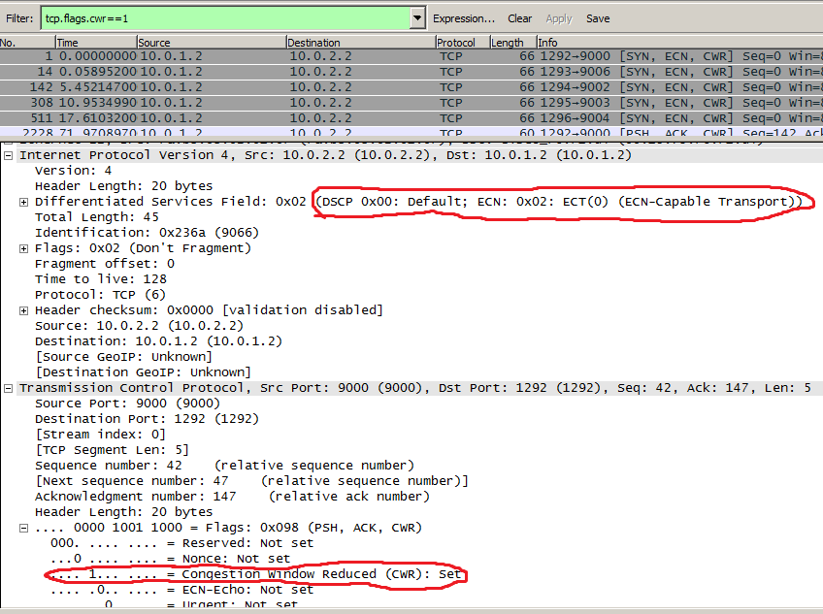

**Štatistiky z D-ITG:**

Podobné straty paketov u UDP toku ako v prípade WRED.

Flow number: 5

From 10.0.1.2:64549

To 10.0.2.2:9005

----------------------------------------------------------

Total time = 62.067000 s

Total packets = 600

Minimum delay = -343.159000 s

Maximum delay = -338.587000 s

Average delay = -339.662600 s

Average jitter = 0.096162 s

Delay standard deviation = 0.823089 s

Bytes received = 307200

Average bitrate = 39.595921 Kbit/s

Average packet rate = 9.666973 pkt/s

Packets dropped = 806 (57.33 %)

Average loss-burst size = 2.276836 pkt

**************** TOTAL RESULTS ******************

__________________________________________________________

Number of flows = 5

Total time = 83.812000 s

Total packets = 2478

Minimum delay = -343.159000 s

Maximum delay = -334.093000 s

Average delay = -339.024997 s

Average jitter = 0.161913 s

Delay standard deviation = 1.714316 s

Bytes received = 1268736

Average bitrate = 121.103040 Kbit/s

Average packet rate = 29.566172 pkt/s

Packets dropped = 806 (24.54 %)

Average loss-burst size = 2.276836 pkt

Error lines = 0